**GeMS: A generic management strategy evaluation framework for fisheries**

Cody Szuwalski1,2*, Qi Lee1,2

1Marine Science Institute, University of California, Santa Barbara, 93117.

2Bren School of Environmental Science and Management, University of California, Santa Barbara, 93117.

* Corresponding author

Email: c.s.szuwalski@gmail.com

# Abstract

Generic Management Strategy Evaluation (GeMS) provides a flexible simulation platform to quantitatively answer questions in fisheries management while incorporating the uncertainty of the management process itself. GeMS uses a two-box, age-structured operating model in which temporal variation in all population and data collection processes is possible. Time-variation in simulated population processes allows the evaluation of the impact of environmental change, shifts in species distribution, and changes in exploitation patterns on management. This variability can have impacts on sustainable yields, but it is often not incorporated into management. Here, we demonstrate the current capabilities of the GeMS framework using two examples. We conclude by discussing potential uses for GeMS and how it complements the existing tools used for management strategy evaluations.

**Introduction**

One of the main goals of natural resource management is to ensure the sustainable exploitation of the resource. However, the definition of sustainability often varies with different stakeholders of that same resource and create conflicts (Anderson et al., 2015; Loring, 2013; Redpath et al., 2013), resulting in the need for clearly described trade-offs and acceptable outcomes to all stakeholders. To do so effectively, we need an understanding of the way the resource would respond to exploitation and future changes to exploitation. This can be a difficult task due to uncertainties inherent in the understanding of an exploited resource’s dynamics and the implementation of management (Kell et al., 2007). In recent years, simulation-based approaches have been increasingly proposed to and used by resource managers to evaluate the performance and risks of alternative management procedures under uncertainty (Punt, 2008; Punt et al., 2016; Rademeyer et al., 2007). Management strategy evaluation (MSE; (Smith, 1994) is one such simulation framework that has been gaining popularity in fisheries management (Bunnefeld et al., 2011; Punt et al., 2016; Rademeyer et al., 2007) and more recently other natural resource management systems (Milner-Gulland et al., 2010). The full process of an MSE involves identifying management objectives, creating simulated populations, developing data collection schemes, and testing different assessment tools, and harvest control rules to evaluate their trade-offs and performance in metrics like long term yield, variability in yield, and probability of overharvesting (A’mar et al., 2009; Punt et al., 2014; Rademeyer et al., 2007). In doing so, it allows for quantitatively comparing the performance of a suite of management strategies (or management procedures, defined as the data collection, method of analysis, consequent management actions, and implementation error; Miller et al., 2018; Schnute et al., 2007) given some assumed underlying dynamics.

MSE has been used for fisheries around the globe to compare and select management strategies robust to various uncertainties. The simulation process can take on a “hypothesis-oriented approach” (Kell et al., 2006; Punt et al., 2014), where alternative models simulate population data that incorporate expert beliefs and different assumptions about population drivers are evaluated. For example, ecological processes are known to vary over time and space due to external factors such as climate change (Hollowed et al., 2013), fishing behavior (Szuwalski et al., 2017a), or regime shifts (Conners et al., 2002; Szuwalski and Punt, 2013a), and these processes will likely continue to fluctuate in the future. However, the effects of such variation on management and a mechanistic understanding of how a population fluctuates over time is often unavailable (Thorson, 2015). As such, it is important to find management strategies robust to fluctuations in the dynamics of the population (Holt and Punt, 2009; Punt et al., 2014; Szuwalski and Punt, 2013b). MSE can be used to evaluate the performance of management strategies under changes in ecological processes by simulating several hypothetical realities in which strategies can be tested. MSEs conducted on walleye pollock (*Gadus chalcogrammus*) found that under changing environmental conditions, keeping the management strategy at status quo had a high probability of resulting in an overfished stock (A’mar et al., 2009; Ianelli et al., 2011). In the Bering Sea, status quo harvest control rules for snow crab (*Chionoecetes opilio*) were found to result in the stock being potentially falsely declared overfished due to regime shifts in the system dynamics (Szuwalski and Punt, 2013b). Managing three subpopulations as a single unit was likely to result in overexploitation at a local level for small yellow croaker (*Larimichthys polyactis*) in the East China Sea (Ying et al., 2011). While the true impact of spatially- and temporally-varying processes on a population remains unknown, simulation allows managers to evaluate management alternatives over different projected ‘states of nature’, and potentially select management procedures that could mitigate for these projected effects in advance.

The examples described above were “case-specific” evaluations, meaning they were tailored to a specific fishery system. They represent a significant investment of time and resources that may not be possible in many fishery systems across the world. In a review of MSE processes, Butterworth and Punt (1999) recommend the development of “case-specific” MSE procedures over “generic” ones, although they acknowledged that a major hurdle to conducting MSEs is a general lack of modelling skills and of software packages that can implement “generalized” operating models. In response, an open-source generic MSE framework, Fisheries Library for R (FLR; (Kell et al., 2007)), was developed to allow scientists to conduct MSEs in a common framework. FLR is a comprehensive package in which the analyst can specify many details of the operating model to directly match a given assessment, including many options to tailor to the given system’s needs, such as socio-economic factors. The learning curve can be steep, which may hinder resource managers and fisheries scientists with less technical capacity from embarking on their own MSEs.

Here we present a Generic Management Strategy Evaluation framework (GeMS) that allows for the rapid testing of management strategy performance over a range of scenarios. Not meant as a replacement for a fully-fledged MSE, GeMS was developed to allow resource managers and fisheries scientists to quickly begin the process of an MSE with relatively simple inputs. GeMS only requires inputs of life history parameters to begin an MSE, but time series of historical fishing effort and recruitment from an existing stock assessment can also be incorporated. GeMS allows, *inter alia*, for time-variation in every population process in the operating model, and also can accommodate movement between two spatially-distinct populations. This may help stakeholders to make a decision on whether effort and resources should be invested in a more exhaustive MSE for their system (e.g. using FLR or a custom-built simulation framework). GeMS is written in R (R Core Team, 2017) and Auto Differential Model Builder (ADMB; (Fournier et al., 2012)), two open-source tools, and the code hosted on Github, in the hope of ensuring ease of use, reproducibility, and transparency (Anderson et al., 2014; Kell et al., 2007).

**Framework**

**General Overview**

MSE is accomplished, after identification of management objectives, by simulating populations with characteristics similar to the target population, drawing data with error from the simulated populations required to assess the stock using a given management strategy, applying an assessment method to estimate quantities used in management (e.g. the current biomass and biological reference points), and finally using a specified harvest control rule to determine the allowable catches in a given year (Fig. 1). The calculated allowable catches are removed from the simulated population and process is repeated into the ‘future’ to mimic the feedback that occurs in the management of an actual fishery (A’mar et al., 2009; Punt et al., 2016; Rademeyer et al., 2007). GeMS uses this general framework, broken into three components:

1. Operating model: The operating model for GeMS is a two-area, age-structured population dynamics model with capacity for time-varying parameters in all population and management (data collection) processes. The model simulates a time series of catch, an index of abundance, and length-composition data based on user-specified observation error.
2. Estimation model: Currently, two estimation models exist: a Pella-Tomlinson generalized surplus production model, and an age-structured model with the capacity to allow growth, recruitment, natural mortality, and selectivity to vary over time.
3. Harvest control rule (HCR): Currently, available HCRs are 1) an exploitation rate fixed at a level defined by the operating model (FMSY), 2) a user-defined fixed catch, 3) a user-defined fixed exploitation rate, and 4) a sloped control rule based on proxies of target biomasses and fishing mortalities estimated by the estimation model.

Punt et al. (2016) described guidelines for best practices in approaching MSE, and we outline the ways GeMS approaches these guidelines in Table 1. GeMS simplifies and speeds up the MSE process by making some decisions for the user about the management procedures, model structure, and performance metrics, while still being flexible enough to accommodate complexity as specified by the user.

**Basic steps to GeMS**

The package can be installed from Github at <https://github.com/szuwalski/GeMS>. After it is downloaded, all that is needed to begin an MSE is a control file. The control file dictates the entire MSE process and includes parameters of the operating model, the properties of the estimation model, and the type of HCR that should be applied. The equations for the entire process can be found in the Supplementary Materials. GeMS comes with a master control file (Master_CTL.csv) to serve as a template, as well as several examples based on a cod-like stock (Hurtado-Ferro et al., 2015). The control file is a comma-separated values (csv) file, and can be modified using any readily-available spreadsheet software such as Microsoft Excel or LibreOffice Calc. A full description of all parameters in the control file can be found on the Wiki for the Github repository containing GeMS. A function call `run_GeMS()` initiates the MSE, and produces basic diagnostics and output, which can then be analyzed by the user according to their needs.

**Examples**

As previously mentioned, temporal variation in population processes is likely to be a widespread and increasingly prevalent problem in fisheries management (Szuwalski and Hollowed, 2016). However, assessment models used in management do not often account for these changes, resulting in harvest control rules that could potentially result in failed management of the stock (Hurtado-Ferro et al., 2010; Johnson et al., 2014; Lee et al., 2017; Szuwalski et al., 2017b). Here, we base our examples on the management of a cod-like population (Hurtado-Ferro et al., 2015) that experienced a regime-shift in its fishery’s selectivity, which could happen when the fishery changes gear types or new technology is developed. This is configured by inputting length at 50% selectivity ( $L_{t}^{50,fish}$ in Supplementary Materials Eq. 6; `sel50n` in the control file) as a vector with a decrease in year 36 (`c(rep(50,n=35), rep(30,n=40))`) in the control file. This syntax should be familiar to most basic R users. Using this example population, we test two research questions using different approaches within the GeMS framework.

**Example 1: Performance of management procedures under temporal variation**

Time-varying biological processes and human (fleet) behaviors require time-varying parameters to represent this variation in the modelled population (Walters and Martell, 2004), often estimated as additional deviations to a mean parameter (Thorson et al., 2015). However, it is often difficult and expensive to obtain information about time-varying processes, and to account for such processes in assessment models. As such, parameters in an assessment model are usually fixed at or estimated as a single value that approximates the average process over time. As mentioned previously, the importance of finding management procedures robust to temporal variation and uncertainty cannot be overstated. Here, GeMS is used to test three management procedures on the simulated population described above. We compare the effects of inflexible management (fixed catch) with more flexible management based advice from an age-structured estimation model, assuming time-invariant selectivity (i.e., the assumptions in the estimation model do not match those of the operating model). Each of the scenarios was specified by changing a few fields in the control file. The management procedures tested were as follows:

1) a constant catch based on an average of the last 20 years’ catch (“Constant Catch”),

2) an F35% based on an estimation model that estimated a single value for $L_{t}^{50,fish}$ (“F35”), and

3) an F35% based on the estimation model as (2) but with a sloped harvest control rule (“Sloped F35”).

With these control files specified, all that is needed to run the MSE is the `run_GeMS` wrapper function (see code below). 100 replicates of the MSE were conducted for each scenario, and each replicate was projected 20 years, conditioned on 50 years of historical data for assessment. GeMS can be run in parallel for multiple operating models by changing a few optional switches in the wrapper function. The example files can be found in the folder ‘inst/extdata/Cod_6_HCR_TimeVary’ of the Github repository.

```

OMNames <- c("Cod_Base", "Cod_F35", "Cod_F35_Slope") # names of the control files

run_GeMS( CTLNameList = OMNames, # vector of control files

runparallel = T, # use parallel processing

cores = 3) # use four cores in parallel

```

GeMS automatically creates a `plots` directory storing figures that compare several estimated model outputs across scenarios, including management reference points, population processes, catch time series, spawning stock biomass. The time series of spawning biomass (Fig. 2) showed that inflexible management based on the historical catch series resulted in a crash of the fishery in as few as ten years into the future. Meanwhile, management based on output from a misspecified age-structured estimation model sustained the population at a relatively constant level for the entirety of the forecasted 20 years.

However, the time series of catch (Fig. 3) showed that managing with an F35% directly from the estimation model led to a rather large variability in catch, which may not be ideal for the participants of the fishery (e.g., processors and fishers). Adding a sloped harvest control rule (Supplementary Materials Eq. 25) did not visually appear to make a difference to this variability in catch, likely as the population appears to be at a relatively stable level. The constant catch harvest control rule, however, had relatively low variability in forecasted catch. It could be argued that a lower catch limit could have been set, but it still may not be flexible enough to accommodate future changes in the population, resulting in a trade-off. It is to be noted that the point of this example was not to identify absolute measures of performance metrics, but to evaluate the performance of each management procedure relative to the others.

**Example 2: Retrospective patterns in age-structured models – an “assessment-based” method**

Retrospective patterns are defined as systematic biases in estimates of derived quantities from a model, given increasing years of data (Mohn, 1999). When retrospective patterns are strong, perhaps due to a misspecified stock assessment model, the model could be rendered unsuitable for management purposes (Hurtado-Ferro et al., 2015). For example, a Pacific halibut (*Hippoglossus stenolepis*) stock assessment was found to have consistently overestimated biomass and underestimated harvest rates (Clark and Hare, 2008; Valero, 2012). This resulted in biased perceptions of stock status and hence inappropriate harvest strategies set for managing the stock (Valero, 2012). One of the ways this could be mitigated is by allowing a process (such as growth, natural mortality, or selectivity) to vary over the time, even if the “true” time-varying process is unknown (Szuwalski et al., 2017b). However, reducing retrospective patterns does not necessarily translate to unbiased management reference points, and GeMS can be used to investigate such a question.

From the previous example, the misspecified estimation model (Scenarios 2-3) showed a slight retrospective pattern (median Mohn’s Rho ≈ 0.1; Fig. 4). However, the population processes in reality that vary over time may not always be known, and misspecifying the process (i.e., specifying a time-varying process in the operating model while allowing another process to vary in the estimation model) sometimes had dramatic consequences on reference points and resultant management advice (Szuwalski et al., 2017b). We assessed the example population with four scenarios based on two estimation model configurations, and varied the amount of data available:

1) an F35% based on an estimation model that estimated a single value for $L_{t}^{50,fish}$ (“Fixed L50”; same as scenario 2 from the first example),

2) an F35% based on an estimation model that estimated a time-varying $L_{t}^{50,fish}$ without a sloped harvest control rule (“Time-vary L50”),

3) an F35% based on an estimation model that estimated a time-varying $L_{t}^{50,fish}$ but with a forecasted doubling of number of length composition samples (“Better Future Data”), and

4) an F35% based on an estimation model that estimated a time-varying $L_{t}^{50,fish}$ but with a quadrupling of number of length composition samples, both historically and in the future (“Better Historical Data”).

Figure 5 shows that convergence rates for the estimation models that estimated time-varying $L_{t}^{50,fish}$ were very low, although performance improved with an increased sample size for length composition data. There was a slight decrease in the median Mohn’s rho when the estimation model was correctly specified that became even more pronounced when historical data were improved (Fig. 6). This reduction in retrospective bias came with a trade-off of increased variability in forecasted catch (Fig. 7) and potential overfishing of the stock (Fig. 8). In this example, the misspecified estimation model outperformed the correctly-specified ones, particularly considering the variability in forecasted catch, brought on by estimating time-varying selectivity. However, it is to be noted that all the estimation models had other life history parameters (e.g., growth, natural mortality) specified at their exact values – a rosy assumption that is unlikely to happen in reality – and more exploration would be necessary before drawing any conclusions on the management of this cod-like fishery.

**Discussion**

From the two simple examples discussed in this manuscript, it would seem that continued sustainable management of this resource would benefit from adaptive management based on an age-structured model and improved data collection (specifically length composition data). While these results are hardly surprising, the two examples here show how GeMS can be used to ask different kinds of questions with relatively simple changes to a control file. In the first example, GeMS was used to identify management procedures robust to uncertainties related to time-varying processes in the fishery, given imperfect information. The second example took a more “assessment-oriented” approach – using simulation to describe the trade-offs associated with reducing model structure uncertainty. However, neither of these examples were comprehensive, and leaves the door open for further analyses (such as what would happen if management was based on output from a production estimation model instead of an age-structured one). Implementing these examples required changing a few fields in the control file, mostly using vectors written in the R syntax. All the figures from the examples were automatically generated from running the `run_GeMS` function, allowing for immediate visual inspection of the results.

In addition to those questions described above, GeMS can also be used to ask more fundamental questions about stock assessment performance over a range of life histories, estimation models, and harvest control rules. Only temporally-varying populations were described here, but GeMS also has a spatial component that allows for two distinct populations that to interact via a movement vector, and as such can also be used to simulate spatially-explicit populations. Marasco et al. (2007) suggested that MSEs could be used to identify candidate management strategies or to identify future research and monitoring goals. For example, GeMS could help to answer questions including (but not limited to) the following:

* What is the value of improved assessment methods or data for assessment?
* How would implementing an MPA or changing gear types impact maximum sustainable yield?
* How does the performance of a management strategy using a production model change (in terms of long term yield) under scenarios in which climate change influences somatic growth?
* How does movement between two populations impact the performance of age-structured assessment methods?
* How would changes in species interactions (via range shifts, for example) influence the potential yield of a given species?

Currently, other MSE packages do exist in fisheries literature (and elsewhere), most notably the aforementioned FLR (Kell et al., 2007) and the Data-Limited Methods Toolkit (DLMtool; (Carruthers and Hordyk, 2018)). DLMtool is framework that evaluates the performance of many data-limited management procedures. Duthie et al. (2018) released a Generalized Management Strategy Evaluation (GMSE) package, with a more stronger focus on socioeconomic constraints and outcomes. GeMS was developed not as a replacement for any of these tools, but as a complement to them. Our hope is that GeMS will be used in the initial stage, where few decisions are necessary to quickly implement a generic MSE, and from those preliminary results generate sufficient interest to justify a fully-fledged MSE that can be specified either from those packages or from scratch. Of course, should the objectives of the management system in question align with those in GeMS, our open-source framework can be customized as the user sees fit. The MSE process is by nature a highly technical endeavor, making it difficult to communicate to non-experts whose feedback and input would be nevertheless valuable (Miller et al., 2018). By removing some of the more complicated decisions required in a fully-specified MSE (as can be done with the aforementioned MSE packages), GeMS can potentially enhance communication among stakeholders and build interest in the early stages of an MSE process.

GeMS provides a simple method to quickly and quantitatively evaluate the performance of management strategies under different states of nature. It allows for variation in all processes in the operating model and providing the option of spatial dynamics, both of which will likely be important considerations under a changing climate. GeMS is not meant as a replacement for stock assessment and will not be able to capture all the idiosyncrasies of existing assessments. Therefore, GeMS is meant as a starting point for stakeholders to assess their needs for a more comprehensive MSE using other software such as those described above or using their own framework.

The code for GeMS is open source and published on Github (<https://github.com/szuwalski/GeMS>) so that users can provide feedback continuously, and an open dialogue between the developers and the users can be established. We hope that GeMS can efficiently evolve to meet additional needs and improve its capabilities through a transparent development and feedback process. Both described examples are included with the package, and can be found with more examples and information in the Github repository and its associated Wiki.

**Acknowledgements**

We would like to thank the David and Lucille Packard Foundation (Grant #2016-64741) and researchers in the Sustainable Fisheries Group at the University of California, Santa Barbara for help in beta-testing.

**References**

A’mar, Z.T., Punt, A.E., Dorn, M.W., 2009. The evaluation of two management strategies for the Gulf of Alaska walleye pollock fishery under climate change. ICES J. Mar. Sci. J. Cons. 66, 1614–1632. https://doi.org/10.1093/icesjms/fsp044

Anderson, J.L., Anderson, C.M., Chu, J., Meredith, J., Asche, F., Sylvia, G., Smith, M.D., Anggraeni, D., Arthur, R., Guttormsen, A., McCluney, J.K., Ward, T., Akpalu, W., Eggert, H., Flores, J., Freeman, M.A., Holland, D.S., Knapp, G., Kobayashi, M., Larkin, S., MacLauchlin, K., Schnier, K., Soboil, M., Tveteras, S., Uchida, H., Valderrama, D., 2015. The Fishery Performance Indicators: A Management Tool for Triple Bottom Line Outcomes. PLOS ONE 10, e0122809. https://doi.org/10.1371/journal.pone.0122809

Anderson, S.C., Monnahan, C.C., Johnson, K.F., Ono, K., Valero, J.L., 2014. ss3sim: An R Package for Fisheries Stock Assessment Simulation with Stock Synthesis. PLOS ONE 9, e92725. https://doi.org/10.1371/journal.pone.0092725

Bunnefeld, N., Hoshino, E., Milner-Gulland, E.J., 2011. Management strategy evaluation: a powerful tool for conservation? Trends Ecol. Evol. 26, 441–447. https://doi.org/10.1016/j.tree.2011.05.003

Butterworth, D.S., Punt, A.E., 1999. Experiences in the evaluation and implementation of management procedures. ICES J. Mar. Sci. 56, 985–998. https://doi.org/10.1006/jmsc.1999.0532

Carruthers, T.R., Hordyk, A.R., 2018. The Data-Limited Methods Toolkit (DLMtool): An R package for informing management of data-limited populations. Methods Ecol. Evol. 9, 2388–2395. https://doi.org/10.1111/2041-210X.13081

Clark, W.G., Hare, S.R., 2008. Assessment of the Pacific halibut stock at the end of 2007. Int Pac Halibut Comm Rep. Assess. Res. Act. 2007, 117–203.

Conners, M.E., Hollowed, A.B., Brown, E., 2002. Retrospective analysis of Bering Sea bottom trawl surveys: regime shift and ecosystem reorganization. Prog. Oceanogr. 55, 209–222. https://doi.org/10.1016/S0079-6611(02)00079-4

Duthie, A.B., Cusack, J.J., Jones, I.L., Minderman, J., Nilsen, E.B., Pozo, R.A., Rakotonarivo, O.S., Moorter, B.V., Bunnefeld, N., 2018. GMSE: An r package for generalised management strategy evaluation. Methods Ecol. Evol. 9, 2396–2401. https://doi.org/10.1111/2041-210X.13091

Fournier, D.A., Skaug, H.J., Ancheta, J., Ianelli, J., Magnusson, A., Maunder, M.N., Nielsen, A., Sibert, J., 2012. AD Model Builder: using automatic differentiation for statistical inference of highly parameterized complex nonlinear models. Optim. Methods Softw. 27, 233–249. https://doi.org/10.1080/10556788.2011.597854

Hollowed, A.B., Barange, M., Beamish, R.J., Brander, K., Cochrane, K., Drinkwater, K., Foreman, M.G.G., Hare, J.A., Holt, J., Ito, S., Kim, S., King, J.R., Loeng, H., MacKenzie, B.R., Mueter, F.J., Okey, T.A., Peck, M.A., Radchenko, V.I., Rice, J.C., Schirripa, M.J., Yatsu, A., Yamanaka, Y., 2013. Projected impacts of climate change on marine fish and fisheries. ICES J. Mar. Sci. 70, 1023–1037. https://doi.org/10.1093/icesjms/fst081

Holt, C.A., Punt, A.E., 2009. Incorporating climate information into rebuilding plans for overfished groundfish species of the U.S. west coast. Fish. Res., Ecosystem Approach to Fisheries: Improvements on Traditional Management for Declining and Depleted StocksAnnual Meeting of the North Pacific Marine Science Organization 100, 57–67. https://doi.org/10.1016/j.fishres.2009.03.002

Hurtado-Ferro, F., Hiramatsu, K., Shirakihara, K., 2010. Allowing for environmental effects in a management strategy evaluation for Japanese sardine. ICES J. Mar. Sci. 67, 2012–2017. https://doi.org/10.1093/icesjms/fsq126

Hurtado-Ferro, F., Szuwalski, C.S., Valero, J.L., Anderson, S.C., Cunningham, C.J., Johnson, K.F., Licandeo, R., McGilliard, C.R., Monnahan, C.C., Muradian, M.L., Ono, K., Vert-Pre, K.A., Whitten, A.R., Punt, A.E., 2015. Looking in the rear-view mirror: bias and retrospective patterns in integrated, age-structured stock assessment models. ICES J. Mar. Sci. 72, 99–110. https://doi.org/10.1093/icesjms/fsu198

Ianelli, J.N., Hollowed, A.B., Haynie, A.C., Mueter, F.J., Bond, N.A., 2011. Evaluating management strategies for eastern Bering Sea walleye pollock (Theragra chalcogramma) in a changing environment. ICES J. Mar. Sci. J. Cons. 68, 1297–1304. https://doi.org/10.1093/icesjms/fsr010

Johnson, K.F., Monnahan, C.C., McGilliard, C.R., Vert-pre, K.A., Anderson, S.C., Cunningham, C.J., Hurtado-Ferro, F., Licandeo, R.R., Muradian, M.L., Ono, K., Szuwalski, C.S., Valero, J.L., Whitten, A.R., Punt, A.E., 2014. Time-varying natural mortality in fisheries stock assessment models: identifying a default approach. ICES J. Mar. Sci. J. Cons. fsu055. https://doi.org/10.1093/icesjms/fsu055

Kell, L.T., De Oliveira, J.A.A., Punt, A.E., McAllister, M.K., Kuikka, S., 2006. Operational management procedures: an introduction to the use of management strategy evaluation frameworks., in: The Knowledge Base for Fisheries Management, Developments in Aquaculture and FIsheries Science. Elsevier, Amsterdam, pp. 379–407.

Kell, L.T., Mosqueira, I., Grosjean, P., Fromentin, J.-M., Garcia, D., Hillary, R., Jardim, E., Mardle, S., Pastoors, M.A., Poos, J.J., Scott, F., Scott, R.D., 2007. FLR: an open-source framework for the evaluation and development of management strategies. ICES J. Mar. Sci. 64, 640–646. https://doi.org/10.1093/icesjms/fsm012

Lee, Q., Thorson, J.T., Gertseva, V.V., Punt, A.E., 2017. The benefits and risks of incorporating climate-driven growth variation into stock assessment models, with application to Splitnose Rockfish (Sebastes diploproa). ICES J. Mar. Sci. https://doi.org/10.1093/icesjms/fsx147

Loring, P.A., 2013. Alternative Perspectives on the Sustainability of Alaska’s Commercial Fisheries. Conserv. Biol. 27, 55–63. https://doi.org/10.1111/j.1523-1739.2012.01938.x

Marasco, R.J., Goodman, D., Grimes, C.B., Lawson, P.W., Punt, A.E., Quinn II, T.J., 2007. Ecosystem-based fisheries management: some practical suggestions. Can. J. Fish. Aquat. Sci. 64, 928–939. https://doi.org/10.1139/f07-062

Miller, S.K., Anganuzzi, A., Butterworth, D.S., Davies, C.R., Donovan, G.P., Nickson, A., Rademeyer, R.A., Restrepo, V., 2018. Improving communication: the key to more effective MSE processes. Can. J. Fish. Aquat. Sci. 76, 643–656. https://doi.org/10.1139/cjfas-2018-0134

Milner-Gulland, E.J., Arroyo, B., Celine, B., Julia, B., Nils, B., Miguel, D.-M., Charles, E., Ana, N., Lucille, P., Slaven, R., Pere, R., Tomaz, S., 2010. New directions in management strategy evaluation through cross-fertilization between fisheries science and terrestrial conservation. Biol. Lett. 6, 719–722. https://doi.org/10.1098/rsbl.2010.0588

Mohn, R., 1999. The retrospective problem in sequential population analysis: An investigation using cod fishery and simulated data. ICES J. Mar. Sci. 56, 473–488. https://doi.org/10.1006/jmsc.1999.0481

Punt, A.E., 2008. Refocusing Stock Assessment in Support of Policy Evaluation, in: Tsukamoto, K., Kawamura, T., Takeuchi, T., Beard Jr, T.D., Kaiser, M.J. (Eds.), Fisheries for Global Welfare and Environment: Memorial Book of the 5th World Fisheries Congress 2008. pp. 139–152.

Punt, A.E., A’mar, T., Bond, N.A., Butterworth, D.S., de Moor, C.L., De Oliveira, J.A.A., Haltuch, M.A., Hollowed, A.B., Szuwalski, C., 2014. Fisheries management under climate and environmental uncertainty: control rules and performance simulation. ICES J. Mar. Sci. J. Cons. 71, 2208–2220. https://doi.org/10.1093/icesjms/fst057

Punt, A.E., Butterworth, D.S., de Moor, C.L., De Oliveira, J.A.A., Haddon, M., 2016. Management strategy evaluation: best practices. Fish Fish. 17, 303–334. https://doi.org/10.1111/faf.12104

R Core Team, 2017. R: A language and environment for statistical computing. R Foundation for Statistical Computing, Vienna, Austria.

Rademeyer, R.A., Plagányi, É.E., Butterworth, D.S., 2007. Tips and tricks in designing management procedures. ICES J. Mar. Sci. 64, 618–625. https://doi.org/10.1093/icesjms/fsm050

Redpath, S.M., Young, J., Evely, A., Adams, W.M., Sutherland, W.J., Whitehouse, A., Amar, A., Lambert, R.A., Linnell, J.D.C., Watt, A., Gutiérrez, R.J., 2013. Understanding and managing conservation conflicts. Trends Ecol. Evol. 28, 100–109. https://doi.org/10.1016/j.tree.2012.08.021

Schnute, J.T., Maunder, M.N., Ianelli, J.N., 2007. Designing tools to evaluate fishery management strategies: can the scientific community deliver? ICES J. Mar. Sci. 64, 1077–1084. https://doi.org/10.1093/icesjms/fsm109

Smith, A.D.M., 1994. Management strategy evaluation – the light on the hill, in: Hancock, D.A. (Ed.), Population Dynamics for Fisheries Management: Australian Society for Fish Biology Workshop Proceedings, Perth, 24-25 August 1993. Australian Society for Fish Biology, Perth, Western Australia, pp. 249–253.

Szuwalski, C.S., Burgess, M.G., Costello, C., Gaines, S.D., 2017a. High fishery catches through trophic cascades in China. Proc. Natl. Acad. Sci. 114, 717–721. https://doi.org/10.1073/pnas.1612722114

Szuwalski, C.S., Hollowed, A.B., 2016. Climate change and non-stationary population processes in fisheries management. ICES J. Mar. Sci. 73, 1297–1305. https://doi.org/10.1093/icesjms/fsv229

Szuwalski, C.S., Ianelli, J.N., Punt, A.E., 2017b. Reducing retrospective patterns in stock assessment and impacts on management performance. ICES J. Mar. Sci. https://doi.org/10.1093/icesjms/fsx159

Szuwalski, C.S., Punt, A.E., 2013a. Regime shifts and recruitment dynamics of snow crab, Chionoecetes opilio, in the eastern Bering Sea. Fish. Oceanogr. 22, 345–354. https://doi.org/10.1111/fog.12026

Szuwalski, C.S., Punt, A.E., 2013b. Fisheries management for regime-based ecosystems: a management strategy evaluation for the snow crab fishery in the eastern Bering Sea. ICES J. Mar. Sci. 70, 955–967. https://doi.org/10.1093/icesjms/fss182

Thorson, J.T., 2015. Spatio-temporal variation in fish condition is not consistently explained by density, temperature, or season for California Current groundfishes. Mar. Ecol. Prog. Ser. 526, 101–112.

Thorson, J.T., Hicks, A.C., Methot, R.D., 2015. Random effect estimation of time-varying factors in Stock Synthesis. ICES J. Mar. Sci. J. Cons. 72, 178–185. https://doi.org/10.1093/icesjms/fst211

Valero, J.L., 2012. Harvest policy considerations on retrospective bias and biomass projections. Int Pac Halibut Comm Rep. Assess. Res. Act. 2011 311–329.

Walters, C.J., Martell, S.J.D., 2004. Fisheries Ecology and Management. Princeton University Press.

Ying, Y., Chen, Y., Lin, L., Gao, T., 2011. Risks of ignoring fish population spatial structure in fisheries management. Can. J. Fish. Aquat. Sci. 68, 2101–2120. https://doi.org/10.1139/f2011-116



Figure 1. Flow chart representing the flow of information through a management strategy evaluation in GeMS.

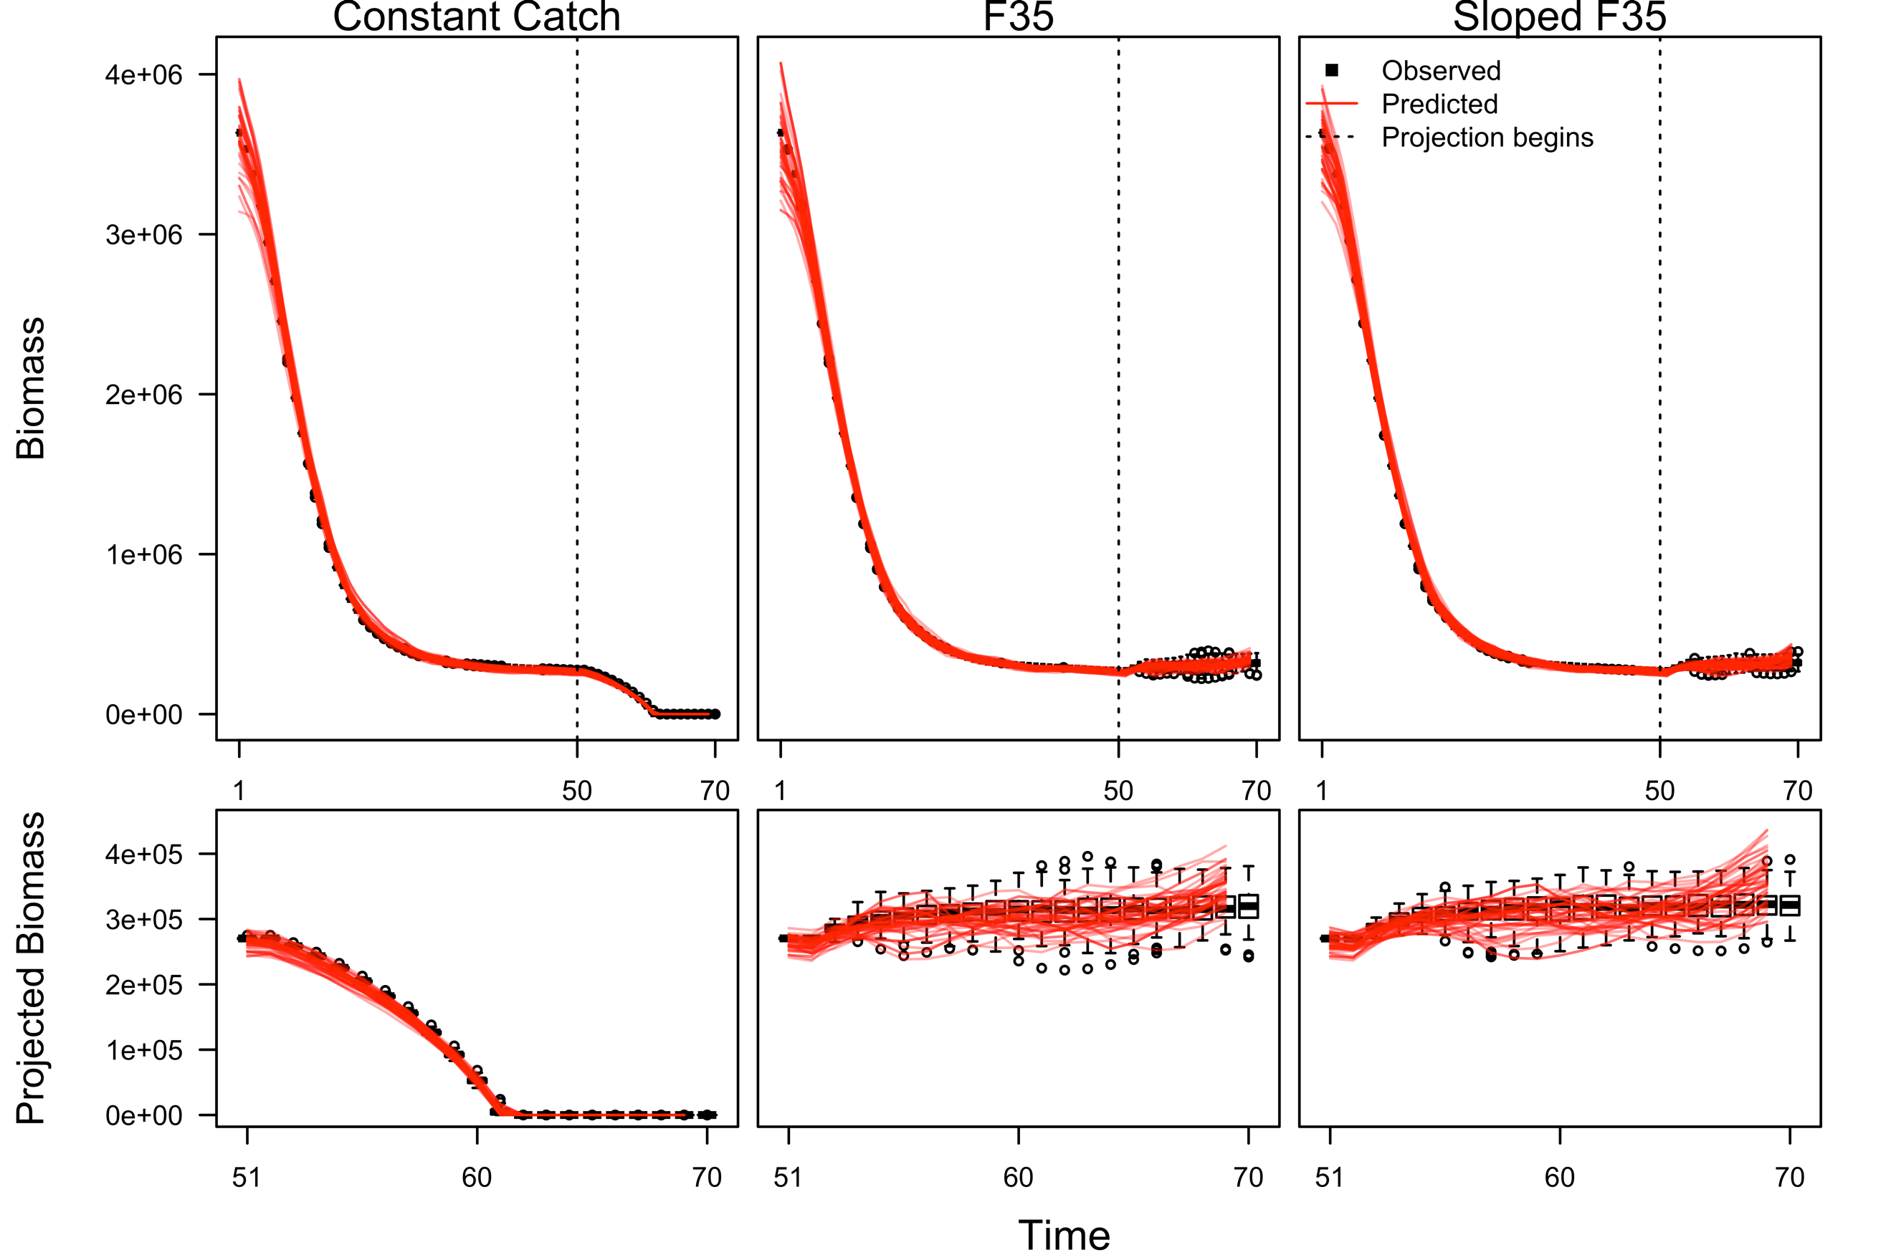

Figure 2. A comparison of spawning biomass estimates

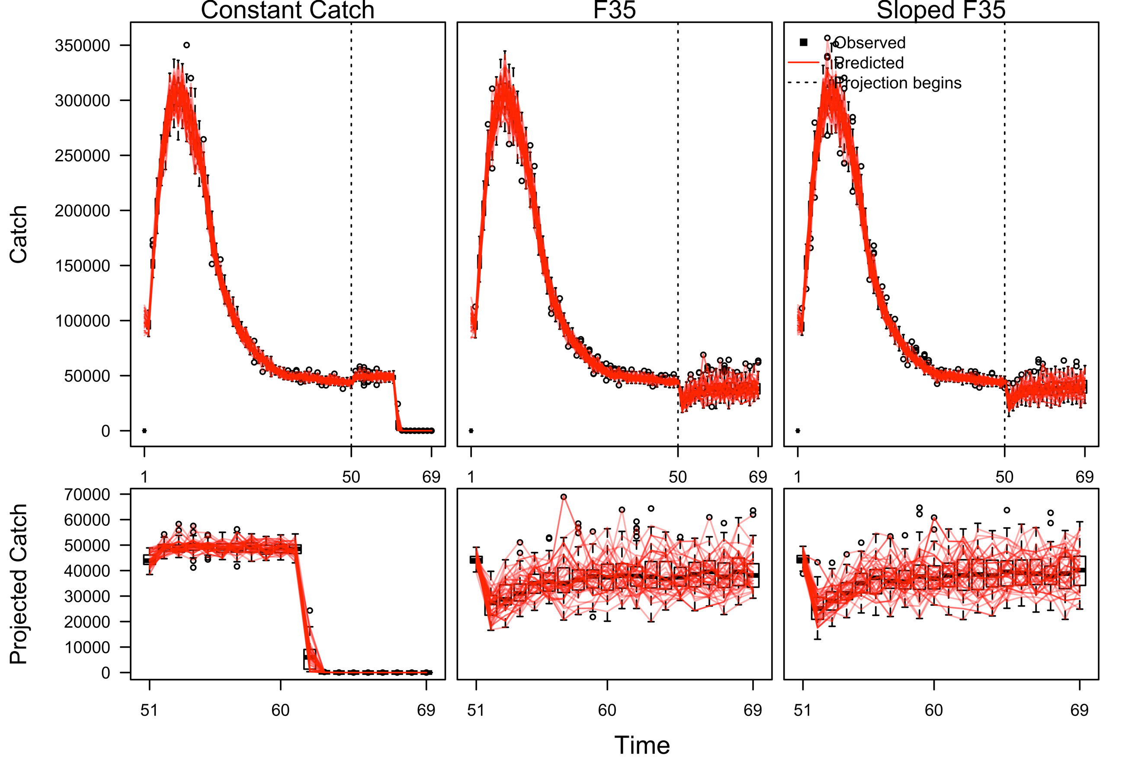

Figure 3. A time series of catch

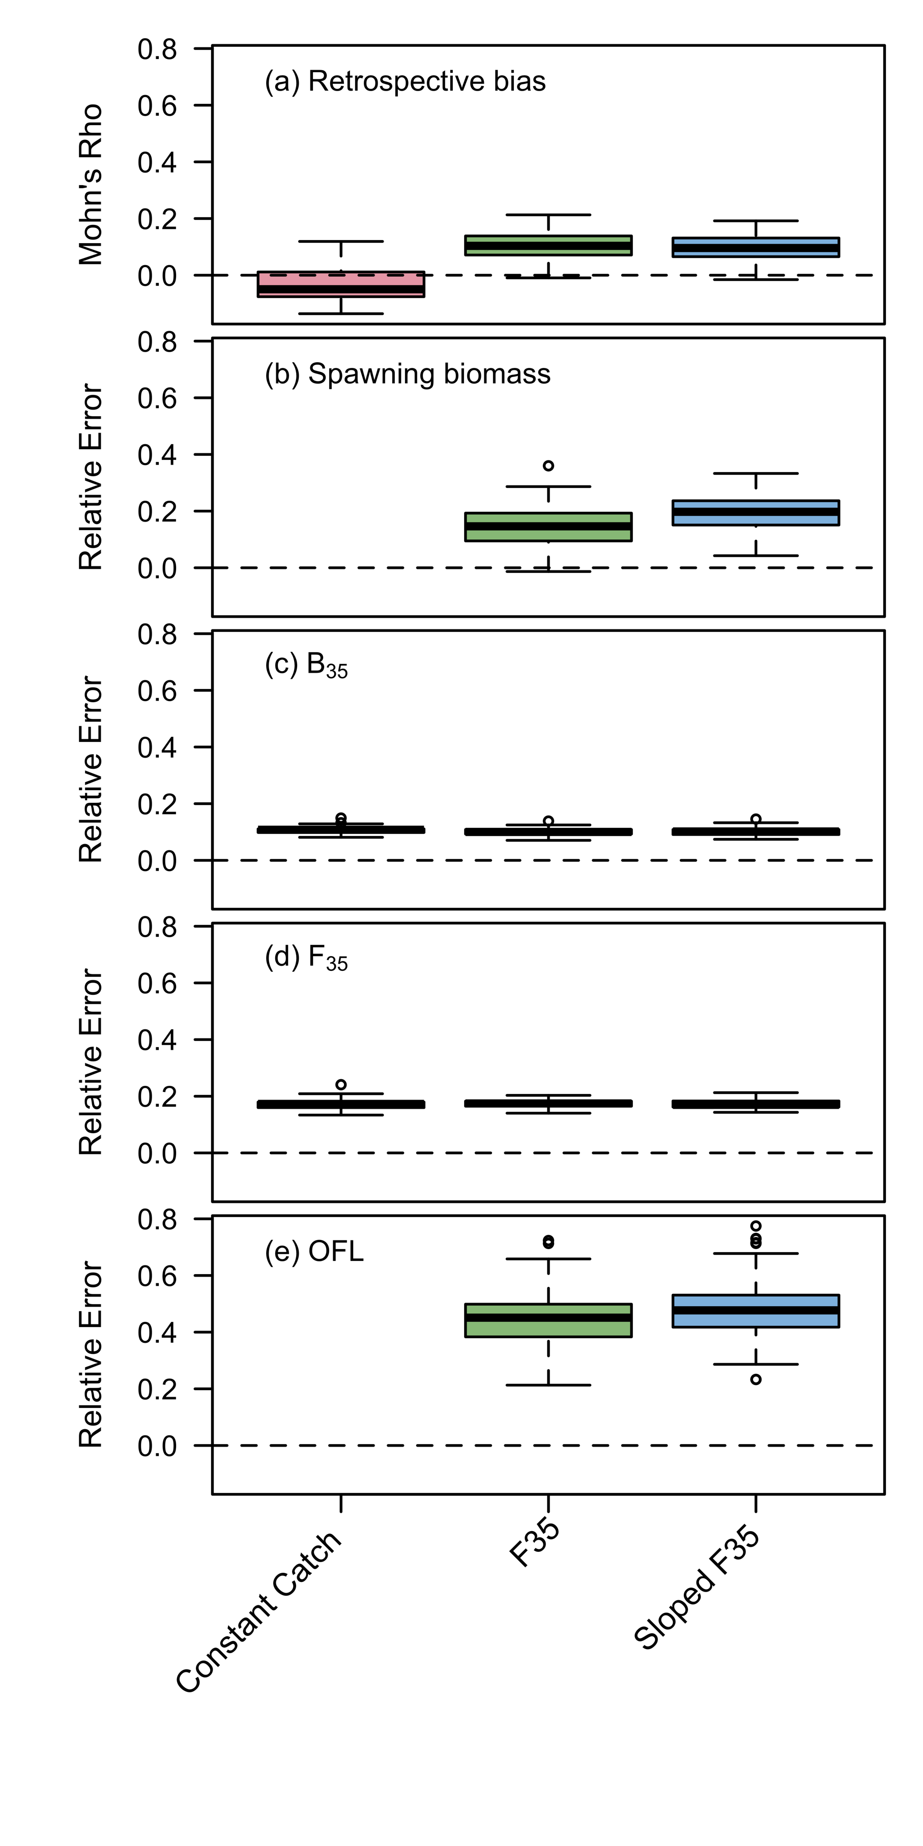

Figure 4. A comparison of reference points estimated from age-structured models for example 1.

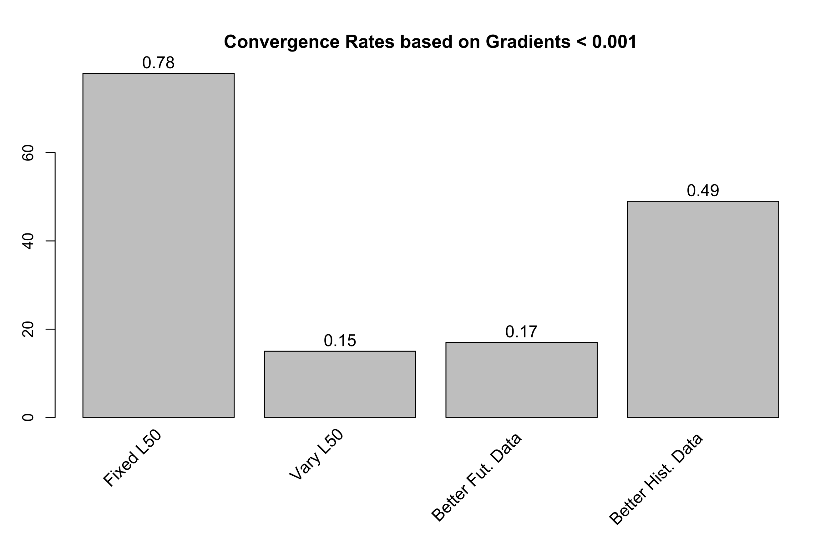

Figure 5. Convergence rates of age-structured estimation models in the final year for example 2.

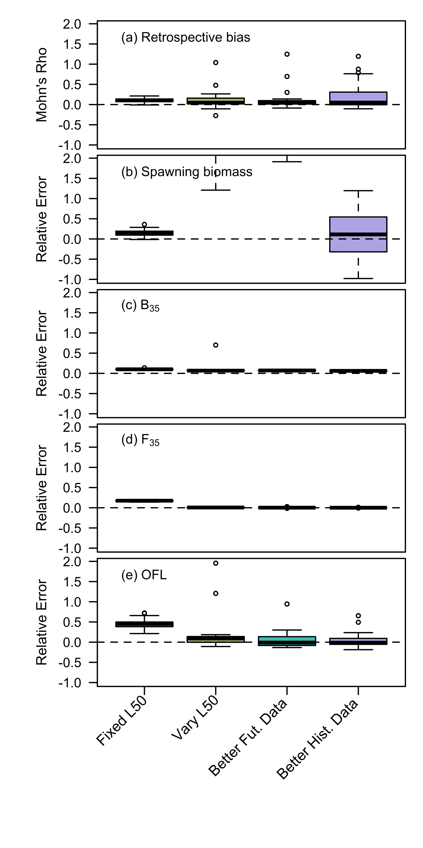

Figure 6. Comparison of reference points estimated in example 2.

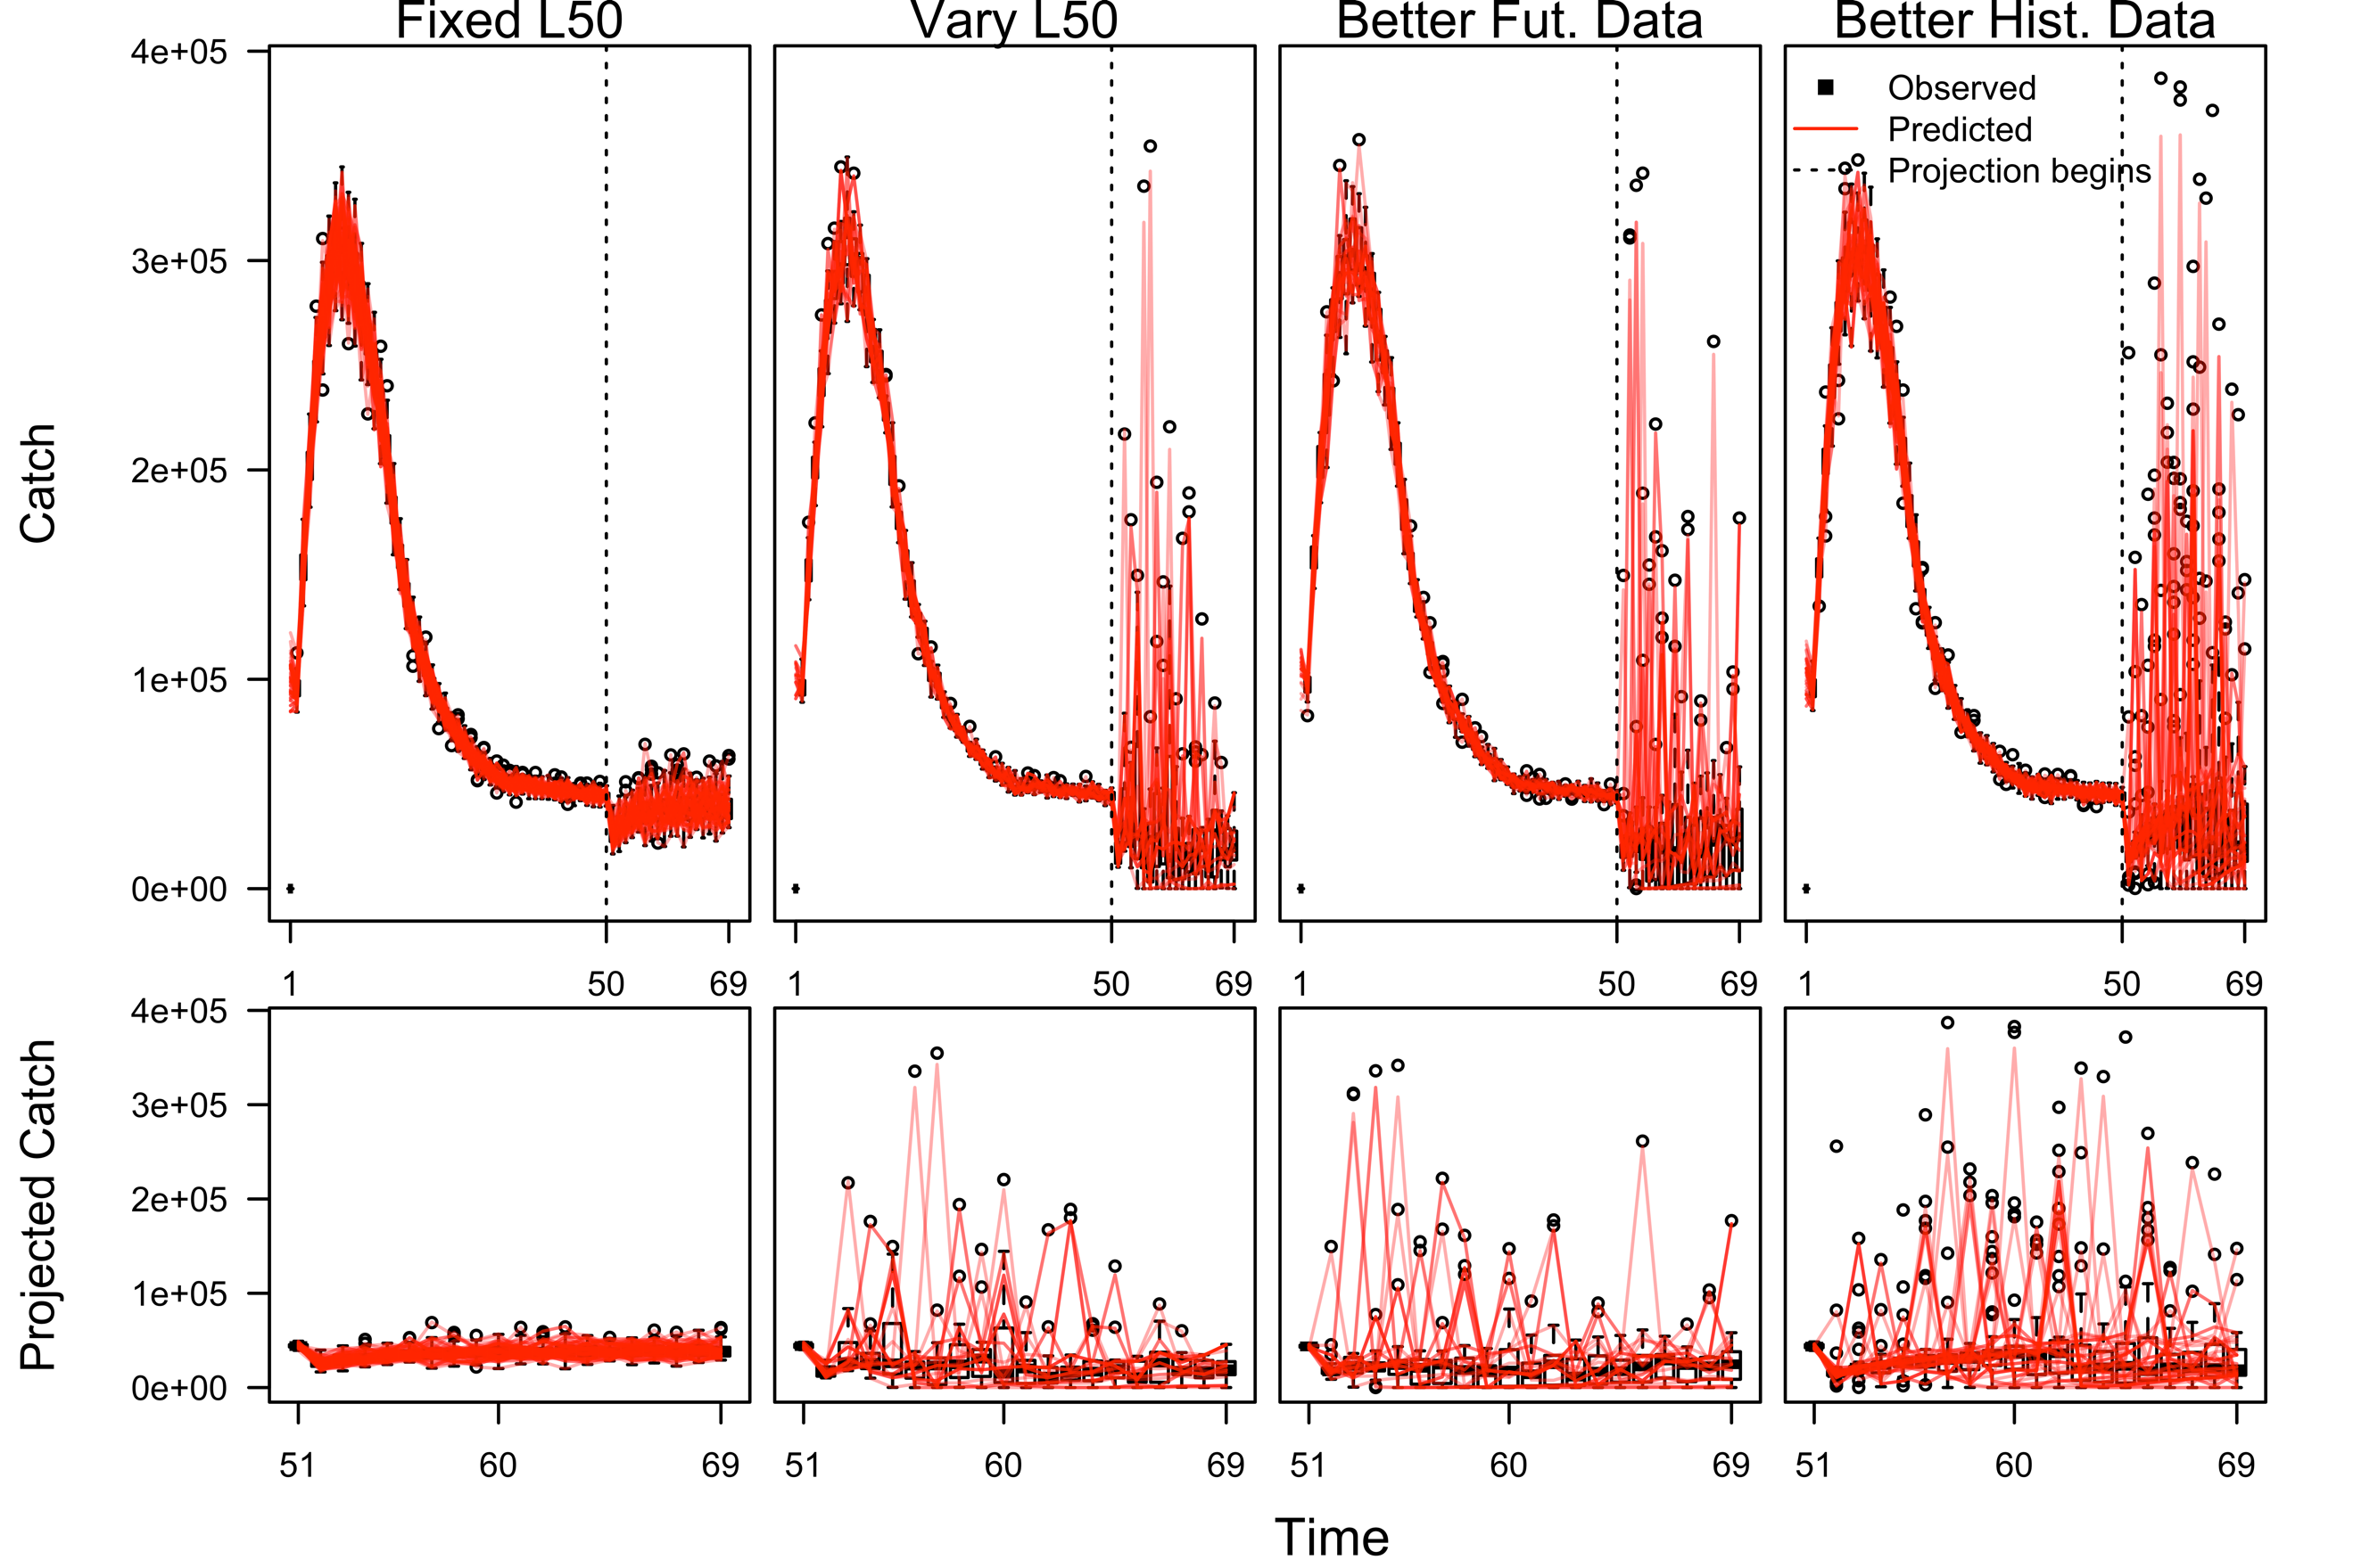

Figure 7. A comparison of the estimated population processes from four age-structured assessment methods applied to an operating model in which selectivity varies over time. The scenarios are described in the manuscript.

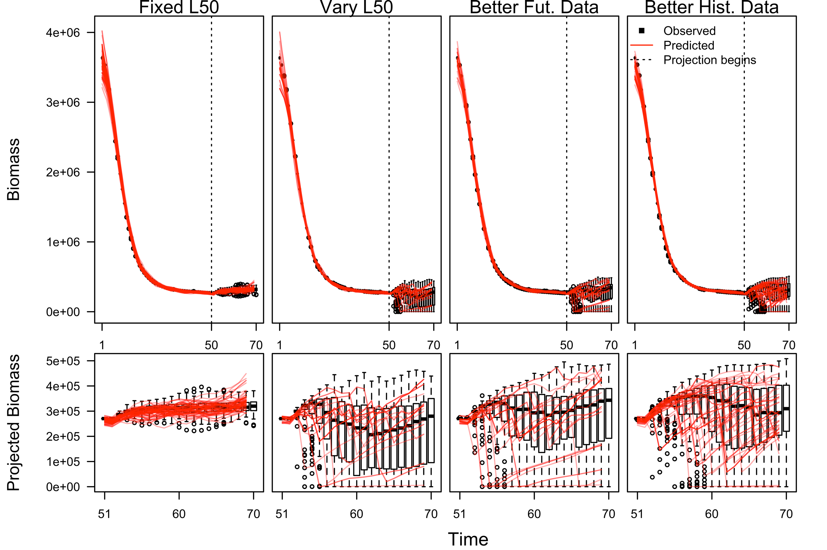

Table 1. Guidelines for best practices in Management Strategy Evaluations and the ways in which GeMS approaches these guidelines.

|  |  |
| --- | --- |
| **Guidelines for MSE best practice as defined by Punt et al. (2016)** | **Ways in which GeMS approaches these guidelines** |
| 1. Identification of management objectives and performance metrics | GeMS includes biological sustainability and precision/lack of bias of derived quantities as performance metrics |
| 2. Identification of a range of uncertainties to test the management strategy against | GeMS allows for temporal and spatial variation, as well as uncertainty in data collection and assessment model processes |
| 3. Development of a set of operating models to represent the systems as identified above | GeMS specifies a general operating model structure |
| 4. Selection of parameters for the operating model | The user fills these into a .csv file, which can be done in a user-friendly interface such as Microsoft Excel |
| 5. Identification of realistic candidate management strategies | The user chooses from four pre-specified harvest control rules: 1. an estimated FMSY; 2. a user-specified constant catch limit; 3. a user-specified constant F; 4. a sloped 40/10 control rule |
| 6. Simulation of each management strategy for each operating model | After the above is specified, a single R function automatically does this |
| 7. Summary and interpretation of the performance statistics | Graphs are automatically produced as a result of the function mentioned above |